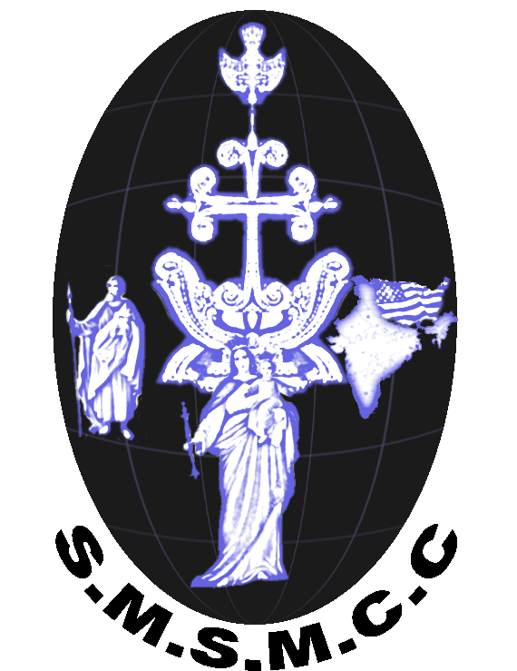
St. Mary’s Syro-Malabar Catholic Church

(St. Thomas Syro-Malabar Catholic Diocese of Chicago)
926 Round Swamp Road, Old Bethpage, NY 11804 Tel:-516-454-7550
Vicar: Rev. John Melepuram
Communion/Confirmation Registration Form – 2022

Candidate Information
Full Name:
Last |  |  | First |  | Confirmation N
Address:
 | DOB: COMM CONFIRM |  |  | COMM & CONFIR
Baptism
 |  | Name of Church, Address (attach copy of the Baptism) record) Certificate) |  |  |  | Date
First Communion
 |  | Name of Church, Address |  |  |  | Date

Registration will be considered approved only after, baptism, communion certificates (if performed outside St.Mary’s parish) & out of parish sponsor letters are submitted and reviewed by vicar

Parents Information
Father’s Name:
Last |  | First |  | M.I.
Mother’s Name:
Last |  | First |  | M.I.
Family Name: |  | ( ) | ( )
 |  | Home Phone No: | Mobile Phone #
Sponsor’s Name:
For Confirmation Only(Parents cannot be sponsor sponsors) |  | Relationship

Church Envelope #: E-Mail ID- Deposit $100
You have the choice to receive the Confirmation also during First Holy communion.
Communion only | Confirmation only | Communion and Confirmation
For Official Use
Holy Communion Yes/No Confirmation Yes/ No Communion Yes/ No
Approved _____________________________________ ______________________
Vicar Date

